White Hot Chocolate & Ube
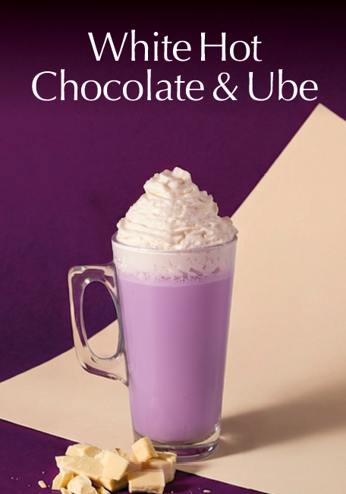
Ingredients / Equipment:
Milk
White hot chocolate syrup & pump
Ube Syrup & pump
Latte glass 14oz

Method:
Add 3 pumps of white hot chocolate syrup and 2 pumps of ube syrup to a jug of milk – whisk together
Steam milk to latte consistency and pour into Latte glass

