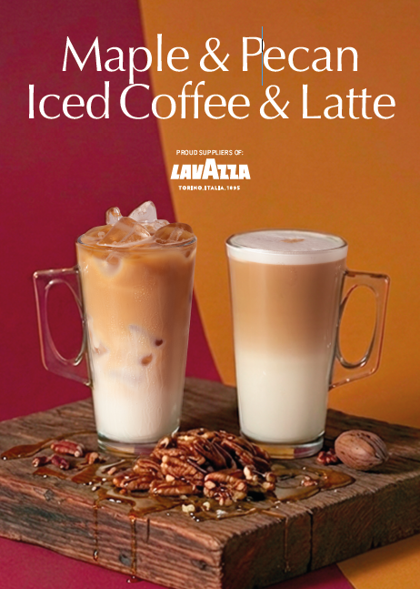
Ingredients / Equipment:
Ice
Coffee
Milk
Maple & Pecan Syrup & pump
Large latte glass / 12oz takeaway cup
Straw (optional)

Method:
Fill Glass with Ice
Pour cold milk 2cm from the top of glass
Extract a double shot of espresso into a small jug.
Add 2 pumps Maple & Pecan syrup into the extracted coffee and whisk
Pour flavoured coffee through top of Latte glass to fill and serve with a straw (optional).

Maple & Pecan Iced Coffee

