Mango & Passionfruit Spritz

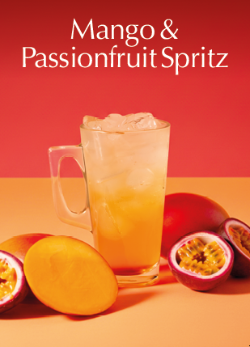
Ingredients / Equipment: (based on 12oz cup)
Ice
Mango & Passionfruit Syrup and Pump
Still / Sparkling Water / Lemonade
Clear cups / lids / glasses
Straws (optional)

Method:
Fill glass / cup with Ice to the top

Fill with still / sparkling water or lemonade to approx. 1cm from the top

Add 3 pumps of Mango & Passionfruit Syrup

Place straw in drink and serve.

