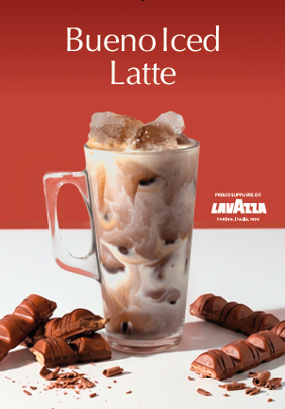
Ingredients / Equipment:
Ice
Coffee
Milk
Hazelnut Syrup & pump
Chocolate Syrup & pump
Large latte glass / 12oz takeaway cup
Straw (optional)

Method:
Fill Glass with Ice
Pour cold milk 2cm from the top of glass
Extract a double shot of espresso into a small jug.
Add 2 pumps chocolate syrup & 1 pump of hazelnut syrup into the extracted coffee and whisk
Pour flavoured coffee through top of Latte glass to fill and serve with a straw. (Optional)

Bueno Iced Latte

