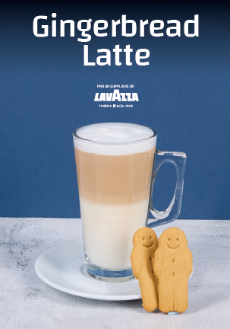
Ingredients / Equipment:
Coffee
Milk
Gingerbread Syrup & pump
Large latte glass

Method:
Extract a double shot of espresso into a small jug.
Add 3 pumps of Gingerbread syrup into the extracted coffee.
Heat latte milk and pour into Latte glass stopping approx. 1cm from the top.
Pour infused coffee into centre of latte milk

Gingerbread Latte

