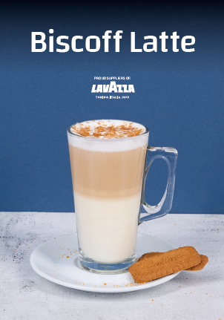
Ingredients / Equipment:
Coffee
Milk
Biscoff Syrup & pump
Biscoff Crumb (optional)
Biscoff Biscuits (optional)
Large latte glass

Method:
Extract a double shot of espresso into a small jug.
Add 3 pumps of Biscoff syrup into the extracted coffee.
Heat latte milk and pour into Latte glass stopping approx. 1cm from the top.
Pour infused coffee into centre of latte milk
Sprinkle Biscoff Crumb across top of latte (if using)
Serve with Biscoff Biscuit (if using)

Biscoff Latte

